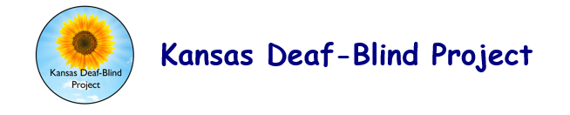

AGENCY REQUEST FOR CONSULTATION
State deaf-blind projects have permission to adapt this tool for use by their own projects. Please include appropriate citation information. For example, "Adapted with permission from [document name, state deaf-blind project name, date (if available)]."

Date of Application: Phone:
School/District Name: Fax:
Contact Person: Position:
Address: E-mail:
In order to effectively meet your technical assistance needs, please complete the following:
- We are requesting technical assistance/consultation to improve:
- Is this child listed on the Deaf Blind Census?
- Describe the type of help you are requesting:
- What do you hope to achieve from this consultation? Describe the desired outcome(s) of the consultation:
- Describe your school setting, size, grade levels, student population, etc. If requesting an individual student consultation, please describe the student’s age, sex, disability(ies), school placement/setting, and grade level:
- When would you like assistance? List preferred dates, days of the week, and times for assistance:
- Other relevant information:
Contact Person Signature:
Administrator Signature:
1.5.15

