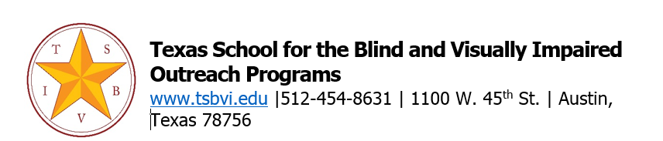
State deaf-blind projects have permission to adapt this letter for use by their own projects. Please include appropriate citation information. For example, "Adapted with permission from [document name, state deaf-blind project name, date (if available)]."
Welcome Families!!
We are excited that your child’s educational team has requested a school consultation from the Texas School for the Blind and Visually Impaired Outreach Department. To help you prepare for our conversation, we’re including some information about the school consultation process.
We will be calling you to discuss our visit and to learn a bit more about your child. That will be the time you’ll have a chance to meet our educational consultant and if possible, our family engagement specialist. They will share with you how the school consultation works (this is covered a bit in the FAQ attachment). It will also be a chance to explore how we can support you in addition to the consultation.

Some of the ways we can assist you include:
- Conversations about family matters, your child's community involvement, school program, and related supports.
- Provide training for your family.
- Help you access financial assistance for travel costs to participate in conferences.
- Explore Family Leadership Training.
- Help you learn more about special education, family organizations, Medicaid waivers, resources for transition to adulthood, and other needs.
If you would like to speak to our family engagement specialist at any time, please feel free to email or call! If your child has vision loss with or without additional disabilities, please contact Rachel Simpson at (512) 206-9418 and simpsonr@tsbvi.edu. If your child has combined vision and hearing loss, please contact Edgenie Bellah at (512) 206-9423 and bellahe@tsbvi.edu.

We look forward to partnering with you!

Cyral Miller,
Director, TSBVI Outreach

