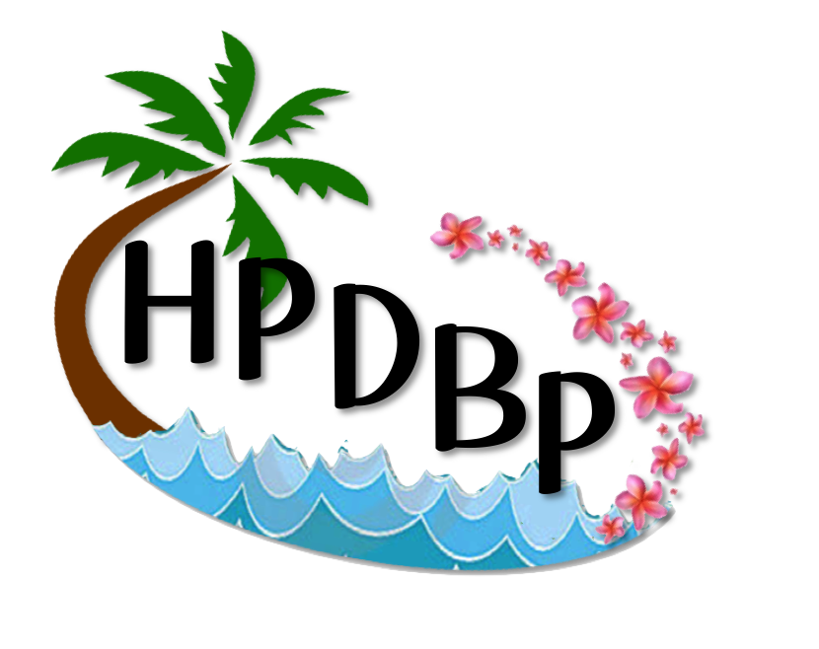Hawai'i and Pacific Deaf-Blind Consortium
Liaison Self-Assessment
State deaf-blind projects have permission to adapt this tool for use by their own projects. Please include appropriate citation information. For example, "Adapted with permission from [document name, state deaf-blind project name, date (if available)]."
Self-Assessment for Focus Child with Deaf-Blindness (5-21)
Quality of Life – Meaningful Participation in Home, School, and Community
[Note: This evaluation was developed as a tool that liaisons working with children who are deaf-blind in Pacific Island nations/jurisdictions can use to assess their practice and TA needs. Each liaison is asked to pick a specific child to use as a focus for the assessment. The tool could be adapted for other uses. For example, for educational teams to assess their use of recommended practices with a specific student.]
AREA | Evidence | 0 | 1 | 2 | 3 | Score/Goals
1a. General Medical  Quality Indicator: Medical plan is in place for student | Observation, interviews, medical document review | Healthy medical check not completed (including checks for otitis media, pink eye, impetigo, bedsores, worms, obesity, diabetes) | Healthy checkup completed &  updated vaccinations, medications | Identification of appropriate medication, lenses, listening devices, or other assistive technology, but may not be available in school program | DB student is maintaining medical plan in place for student, medications taken;
1b. Audiological | Observation, interviews, medical document review | Hearing assessment not completed | Student has hearing assessment | Functional hearing assessment completed if necessary | Complete audiological assessment
1c. Vision | Observation, interviews, medical document review | Vision assessment not completed | Student has vision assessment | Functional vision assessment completed if necessary  Student on current deaf-blind census | Student uses corrective lenses, assistive learning devices  Complete vision assessment
2. Nutrition  Quality Indicator:  Student has appropriate diet and positioning to support their nutritional needs | Observation, interviews,  document review (medical documents,  diet calendars) | Nutrition has not been addressed,  including special dietary needs for focus child (e.g., diabetes, obesity, caloric intake) | Training has been provided to family around basic nutrition, including feeding. Evidence of some nutritional planning. | Family has been provided training on food preparation and feeding specific to their own child and family. Evidence of providing some appropriate diet choices for child. | DB student has a nutritious diet appropriate to their health needs, including feeding & positioning techniques
3. Home  Quality Indicator:  Student participates with family in all  home activities | Interviews,  observation | Does not participate in home/family routines | Family routines have been identified (e.g. meals, celebrations, leisure). DB child occasionally included in activities. | Family has been trained to assist their child in routines. DB student is beginning to partially participate in 2 or more routines. | DB student regularly participates in all family activities and routines (family meals, celebrations, chores, leisure with sibs).  Some family activities planned with DB child’s interests/needs included.
4. Community  Quality Indicator:  Student participates with family in community activities | Interviews,  observation | Does not leave home | Community activities and routines have been identified. DB child occasionally included in community activities | Family has been trained to assist child in community routines. Child is beginning to partially participate in 2 or more routines. | Student regularly participates in all community activities and routines (e.g., church, grocery store, visiting relatives, games)
5. Communication  Quality Indicator:  Student effectively communicates with appropriate system if needed  Note: This is for DB students who are not using ASL as primary means of communication | Observation,  written program, IEP communication goals and objectives, interviews | No communication systems in place | Assessment has been completed and communication systems have been identified  (e.g., give examples, ASL, picture books, greeting, response routine, combination) | Team has been trained on communication system implementation. Implementation of communication system is in place across some environments and activities. | DB student effectively uses a communication system that is reciprocal in nature and used across environments
6. School  Quality Indicator:  Student actively participates in an ASL language-rich educational environment  (for DB students who use ASL or are able to use ASL as an effective means of communication and instruction) | Observation, interviews, document review (IEPs,  student schedule) | Does not attend school | Attends regular or separate class (i.e., Special Ed) with no access to communication or instruction (teachers and peers do not use ASL) | DB student participates in Deaf Ed environments with teachers/aides who have varied levels of fluency in ASL. DB students receive instruction in a limited language-rich environment with peers (ASL class) | DB student receives instruction in ASL language-rich environment for the majority of their school day but has access to general ed classes with well-prepared teachers/support staff
7. Integrated Services  Quality Indicator:  Delivery is provided by student’s team in integrated environments | Schedules, activities, routines | Identified related services are provided in isolation only | Training for the identification of routines in home, school, and community has been provided for integrated service delivery | Some identified service delivery is provided to support students in accessing typical routines in home, school, and community | Service delivery is provided in home, school classroom, and community environments by teachers (Gen Ed and SPED) and related service providers
8. Access to Core Curriculum  Quality Indicator:  Student has appropriate supports to participate in Common Core curriculum | Schedule (service providers, student, classroom) | DB student does not participate in Core curriculum | Some effort has been made for student to be instructed in Core curriculum | Major efforts are underway to include student in as much of the Core curriculum as possible  (with accommodations and adaptions) | DB student has access to Common Core curriculum with appropriate supports, accommodations, and adaptations as needed  (i.e., braille, O&M, ASL)
9. Instruction  Quality Indicator:  Data-driven, systematic instruction is provided by student team members across home, *school, & community environments | Observation, lesson plans,  data | Data-driven, systematic instruction based on appropriate assessments is not in place | Some systematic instruction is in place, but all team members have not been trained to implement | Major efforts are underway to provide data-driven, systematic instruction for portions of the student’s day | Data-driven, systematic instruction is provided by student team members across home, *school, & community environments  (*school access and meaningful participation in the core curriculum)
10. Social Networks/Friends  Quality Indicator:  Student has a social network of age-appropriate peers and is supported as necessary | Circles of Support,  interviews | Does not have access to peers (age appropriate or peer mentors) | A Circle of Friends has been developed by school and/or family, and peers have been identified to be involved with child | Peer group has been developed and trained as necessary, activities have been identified, and child is beginning to participate in selected activities with peers | Student participates with peers in school, home, and community activities and has an ongoing Circle of Support or Peer Network
11. Transition  (Post-School)  Quality Indicator: ITP has been developed and is being implemented | Transition plan, ITP | No ITP in place | Training has been provided on Person-Centered Planning, and  Person-Centered Plan has been conducted which includes student | Action plan has been developed from Person-Centered Plan | ITP is being implemented at home, school, and identified community environments

HPDBC RENEWABLE ACTION PLANNING TOOL
What are the highest priority needs for the focus child?
Rank the following areas with 1 being the current highest priority, 2 being the second highest, etc. until you reach 11.
Area | Rank | TA planned using local resources? (yes/no)  What? | TA you will be requesting from HPDBC project?
Medical
Nutrition
Home
Community
School
Integrated Services
Access to Common Core
Instruction
Communication
Social Networks/Friends
Transition

