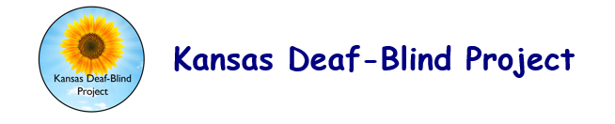

TECHNICAL ASSISTANCE CONSULTATION AGREEMENT

Required

State deaf-blind projects have permission to adapt this tool for use by their own projects. Please include appropriate citation information. For example, "Adapted with permission from [document name, state deaf-blind project name, date (if available)]."

The Kansas Deaf Blind Project provides technical assistance to school district personnel who provide services to children with deaf-blindness and their families. The project is committed to the best educational practices implemented by collaborative teams that lead toward inclusion, individualization, functional student outcomes, interdependence, and full participation in school and society. These services are provided at no cost to the school district from a federally funded grant.

As you know, the Kansas Deaf-Blind staff member assigned to you is:

She can be reached at:
This Consultation Agreement is with:

Site Contact Person _____________________ School/District ________________________

Phone _________________________________ E-mail ______________________________

The Kansas Deaf-Blind Project staff member’s roles and responsibilities include:
- Providing teams with an agreement to deliver consultative assistance.
- Developing consultative objectives and agreements with each team (to the greatest extent possible). These objectives will be based on the information provided by the team. Preliminary objectives are listed below and will be refined at the time of the consultation.
[Insert objectives here]
- Scheduling consultation during times that are convenient for all members involved. The preliminary schedule of activities is listed below. Follow-up activities are considered part of the consultation process and are included in the preliminary schedule.
[Insert preliminary schedule here]
- Informing the contact person in a timely fashion if the consultation must be rescheduled.
- Determining with the team the types of follow-up activities to be conducted.
- Providing the team a means to evaluate the consultation process and services.
- Possibly contacting team members prior to visit or as an element of follow-up.
- Providing copies of notes and forms used during a team meeting.
- Providing a formative report at the time of the consultation and a summative report at the consultation’s end.

The Site Contact Person’s roles and responsibilities include:
- Obtaining permission to videotape as part of the consultation process.
_____ necessary to this consultation _____ unnecessary to this consultation
- Identifying all staff members who need to be aware of the consultant’s role.
- Obtaining signatures of staff members and families for sharing information.
- Assuring, along with the administrator, that staff members are available and prepared to meet with the Kansas Deaf-Blind staff member as needed on scheduled visits.
- Contacting the Kansas Deaf-Blind Project staff member if the student is ill, staff members are unavailable to participate, or if the consultation needs to be rescheduled.
- Assuring, along with an administrator, that the entire team understands their responsibilities for participation and implementing recommendations.

Team members involved in this consultation will include (list name and role for each person):
Signatures

Administrative Representative of the School District, Date

Parent Signature, Date

Person Responsible for Implementing Outcomes Signature, Date

Kansas Deaf-Blind Project Staff Signature, Date

1.9.14

